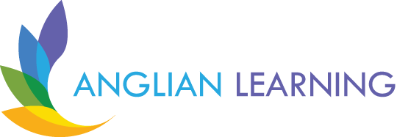

Dynamic, empowered learners who thrive and lead in
their communities: locally, nationally and globally

Fen ditton primary school

RElationships Education and Health Education
policy

This policy was  Approved: | jULY 2026
Policy Version: | 1
this policY will be reviewed: | july 2027
member of staff with responsibility for review: | EMILY THOMPSON- EXECUTIVE HEADTEACHER
this policy WAS CONSULTED WITH: | PSHE Leads across anglian learning
this policy WAS DISTRIBUTED TO: | Staff, parents and carers and available on the school website

Introduction
This policy sets out the school’s approach to Relationships, Health and Sex Education (RSHE). It ensures full compliance with statutory guidance (including requirements effective from September 2026) and reflects a relational, inclusive approach to teaching and learning.
RSHE is delivered as part of a wider commitment to creating a safe, respectful environment where pupils feel valued and able to participate. It recognises that pupils are more likely to engage, attend and learn effectively when they experience a strong sense of belonging within the school community. It explores risks, choices, rights, responsibilities and attitudes, whilst enabling pupils to develop the knowledge and skills needed to keep themselves safe emotionally and physically, both on and offline.
This policy is underpinned by an ethos and commitment to respect and tolerance.
At Fen Ditton Primary, we believe that high-quality Relationships Education is a fundamental part of safeguarding, personal development and inclusion. Through a carefully sequenced and age-appropriate curriculum, pupils are supported to develop the knowledge, language, confidence and relational skills needed to build positive relationships, keep themselves safe, and participate successfully in school and wider society.
Our Relationships Education curriculum reflects the Anglian Learning’s Belonging by Design strategy and recognises that children learn best within environments characterised by safety, connection, consistency and respect. The curriculum is underpinned by the understanding that a strong sense of belonging is protective for children’s emotional wellbeing, attendance, behaviour and safeguarding.
In line with statutory guidance, Relationships Education is taught to all pupils. The school may also choose to teach aspects of non-statutory sex education, beyond the National Curriculum for Science, in order to prepare pupils for puberty and adolescence in a safe, informed and developmentally appropriate way. Where this is the case, the school will clearly identify this content to parents.
The curriculum is designed to:
• support pupils to develop healthy, respectful and caring relationships
• promote kindness, empathy, inclusion and self-respect
• develop pupils’ understanding of personal boundaries, privacy and consent in age-appropriate ways
• equip pupils with the knowledge and confidence to recognise unsafe situations and seek support
• prepare pupils for the opportunities, responsibilities and experiences of later life
• support pupils to understand diversity within families, friendships and communities
• promote positive mental health, emotional literacy and safe decision-making
• develop pupils’ understanding of online relationships, digital safety and healthy use of technology
- Definitions
Relationships education teaches the fundamental building blocks and characteristics of positive relationships. Relationships education refers to teaching about families, friendships, respectful relationships, online relationships and personal safety. It does not include detailed teaching about sexual activity.
Sex Education (where taught) refers to learning about human reproduction beyond the national curriculum for science, including conception and birth in an age-appropriate way.
Health education teaches pupils about their physical health and wellbeing, how they are interlinked, and how to recognise what is normal and how to seek early support as required.
The above will hereafter be referred to collectively as Relationships Education.

- Statutory Requirements
Fen Ditton Primary complies with statutory guidance for:
- Relationships Education (compulsory)
- Health Education (compulsory)
- Sex Education (non-statutory in primary, where delivered)
This policy outlines the legal framework around relationship education, how the curriculum is planned, quality checked and clarification of parental rights regarding withdrawal from non-statutory sex education. Parents should be aware that our academies must uphold the legal duties set out in the Equality Act 2010 and not discriminate against anyone with protected characteristics.
All statutory content is taught to all pupils.
This policy adheres to the following statutory guidance and legal requirements:
- DfE Relationships Education, Relationships and Sex Education (RSE) and Health Education Statutory Guidance (2026)
- The Equality Act 2010
- The Children and Social Work Act 2017
- The Education Act 2002
- Keeping Children Safe in Education (latest version)
- Sections 406 and 407 of the Education Act 1996
- The Public Sector Equality Duty (section 149 of the Equality Act 2010)

- Roles and Responsibilities

Governing Board / Trustees: Are responsible for approving the policy. The Governing Board/Trustees will receive periodic updates regarding statutory compliance, curriculum implementation and safeguarding themes arising from Relationships Education.

Anglian Learning Executive Leadership Team: Are responsible for ensuring that the Headteacher has the appropriate oversight and quality assurances processes in place. They will work with headteachers to review compliance with this policy.

Headteacher (together with RSHE leads): Ensures the curriculum is sequenced, parents are properly consulted, staff are appropriately trained, and assures high quality teaching of relationships education.
Teachers: Deliver RSHE in a sensitive, inclusive way, modelling positive attitudes, and managing tricky questions in a compassionate way.
DSL: Oversees safeguarding and potential disclosures as well as advising on curriculum content and contextual matters.
- Intent of our Relationships Education Curriculum
Through the delivery of Relationships Education, we intend to further our school’s aims of providing a curriculum which is relevant to the needs of pupils, both now and in the future. It will enable pupils to develop knowledge, skills and attitudes which enhance their personal development and wellbeing. This will have a direct, positive effect on their progress and achievement in school. All adults in school will work towards achieving these aims for Relationships Education.

We seek to enable our children to:
• develop interpersonal and communication skills
• develop positive, personal values and a moral framework that will guide their decisions and behaviour
• respect themselves and others, their views, backgrounds, cultures and experiences
• develop respectful, caring relationships based on mutuality, reciprocation and trust
• develop their ability to keep themselves and others safe, physically and emotionally, both on and offline
• develop their understanding of a variety of families and how families are central to the wellbeing of children
• recognise and avoid coercive and exploitative relationships, understanding that these can happen both on and offline
• explore relationships in ways appropriate to their age and stage of development
• be safe through boundaries, privacy, understanding that a person’s body belongs to them, responding appropriately to adults, and recognising and reporting when they feel unsafe
• build confidence in accessing additional advice and support for themselves and others.
- move confidently and responsibly into adolescence
Relationships Education and Health Education will be delivered in a way that is factually accurate, age-appropriate, safeguarding-led and free from political or ideological bias. Teaching will promote respectful behaviour, challenge harmful stereotypes, and support pupils to develop the knowledge and skills needed to stay safe, particularly in online contexts.

- Curriculum Design and Sequencing
The Relationships Education curriculum is planned as part of a broader personal development and wellbeing offer and is delivered through a carefully sequenced programme across all year groups. Learning is revisited progressively so that pupils build knowledge, confidence and understanding over time.
The curriculum is:
- Carefully sequenced from EYFS to Year 6
- Developmentally appropriate, building knowledge and understanding over time
- Cumulative, enabling pupils to revisit and deepen understanding of key themes
- Responsive to safeguarding priorities and pupil need
The sequencing of the curriculum ensures that pupils:
- Begin by developing an understanding of relationships, feelings and safety
- Progress towards understanding boundaries, respect and difference
- Develop age-appropriate knowledge of physical development and puberty
- Build confidence in recognising risk and seeking support
The curriculum includes teaching about:
• families and people who care for us
• caring friendships and respectful relationships
• kindness, empathy and inclusion
• personal boundaries and privacy
• recognising and responding to unsafe situations
• bullying, discriminatory behaviour and peer conflict
• online relationships and online safety
• emotional wellbeing and self-respect
• physical health and mental wellbeing
• puberty and changing bodies
• age-appropriate preparation for adolescence
The curriculum is designed to support pupils before risks occur, rather than responding only after concerns arise. Particular consideration is given to safeguarding themes such as online harms, coercion, peer pressure, unhealthy relationships, discriminatory language and child-on-child abuse.
The curriculum contributes significantly to pupils’ wider personal development. It supports pupils to develop confidence, self-respect, emotional literacy, respectful behaviour and an understanding of diversity, preparing them positively for life in modern Britain and future relationships.
  - Curriculum Structure, content and overview
RSE is delivered through
- Timetabled PSHE lessons
- Assemblies and pastoral systems
- Links with other curriculum areas
Teaching is primarily delivered by class teachers and may be supported by trained staff or external visitors (in line with safeguarding procedures).
The curriculum overview can be found in Appendix A and published on the school website.

- Teaching approaches
Teaching is structured, discussion-based and delivered within safe, respectful environments.
Teaching Relationships Education is highly valuable, however, we recognise that staff require ongoing opportunities to develop their knowledge, confidence and professional understanding. We recognise that every adult has their own personal beliefs and attitudes, but that all teachers must understand and comply with their duties connected with safeguarding, equality and inclusion.
Teachers have a duty to deliver statutory areas of the curriculum and all teachers will be supported to develop their skills in delivering non-statutory areas such as sex education. We will discuss relevant issues and staff concerns and, where appropriate, arrange training to enable staff members to feel confident in delivering the various aspects of Relationships Education. We will also encourage the sharing of good practice.
Our teachers recognise the importance of
- Setting clear expectations
- Using appropriate language
- Managing sensitive topics carefully
- Answering questions clearly, honestly and in an age-appropriate manner
If questions go beyond the curriculum, teachers will respond appropriately and may follow up individually, both with pupils and parents.

- Engaging with Pupils

We will involve pupils in the evaluation and development of their Relationships Education in ways appropriate to their age.

- We will seek opportunities to discuss children’s views about the content of their PSHE lessons.
• We will encourage pupils to ask questions as they arise by providing different means to communicate.
• We will ask pupils to reflect on their learning and set goals for future learning.
• We will consult pupils (e.g. through School Council and pupil voice monitoring) about their perception of the strengths of our Relationships Education provision and the areas to be further developed.

  - Assessment and Progression
RSE is not formally assessed in the same way as academic subjects; however, the school will:
- Monitor pupil understanding through discussion and reflection
- Use teacher judgement to identify gaps in understanding
- Adapt teaching to ensure all pupils can progress

- Inclusion and Equality
The school is committed to ensuring that Relationships Education is inclusive, accessible and meaningful for all pupils. Teaching reflects the Equality Act 2010 and supports pupils to understand and respect difference, diversity and individual experiences.
Teaching will be delivered in a way that is respectful of protected characteristics as defined within the Equality Act 2010.
Relationships Education will be taught in a way that:
• reflects a wide range of families, relationships and lived experiences
• promotes dignity, respect and inclusion
• challenges stereotypes, prejudice and discriminatory behaviour
• supports pupils to understand protected characteristics in an age-appropriate way
• ensures that no pupil feels marginalised or excluded because of their background, identity, family circumstance or additional need
The school recognises that pupils with SEND may be at increased vulnerability in relation to bullying, exploitation, online harms, social isolation and unhealthy relationships. Teaching will therefore be adapted appropriately to ensure that pupils develop the knowledge, communication skills and understanding needed to keep themselves safe and participate successfully in relationships and wider society.
- Safeguarding and pupil safety
Relationships Education forms an important part of the school’s wider safeguarding curriculum. Through the curriculum, pupils are taught how to recognise healthy and unhealthy behaviours, understand personal boundaries, seek support and report concerns.
Teaching is carefully planned to ensure that safeguarding themes are addressed in an age-appropriate and developmentally suitable way. This includes learning related to:
• personal safety
• trusted adults and help-seeking
• online safety and digital behaviour
• bullying and discriminatory behaviour
• privacy and consent
• peer pressure and coercion
• child-on-child abuse
• harmful online content
• emotional wellbeing and healthy relationships
Staff delivering Relationships Education understand that discussions may lead to safeguarding disclosures or welfare concerns. All staff are trained in safeguarding procedures and understand their responsibilities in relation to information sharing, confidentiality and reporting concerns.
Relationships education supports safeguarding and aligns with:
- Safeguarding Policy
- Behaviour Policy
- Online Safety Policy
Where external visitors contribute to Relationships Education, they will do so under the direction and supervision of school staff and within the expectations of this policy, safeguarding procedures and curriculum framework. External visitors supplement, rather than replace, the role of the class teacher.

- Parental Engagement and Right to Withdraw
The school recognises that parents and carers are the primary educators of their children in relation to relationships and wellbeing. The school is committed to working in partnership with families and to providing clear, transparent information about the curriculum.
Parents and carers will be informed about:
• the statutory requirements for Relationships Education
• the content of the curriculum and when topics are taught
• any non-statutory sex education content delivered by the school
• the school’s approach to safeguarding, inclusion and sensitive topics
• their right to request withdrawal from non-statutory sex education
Curriculum overviews and policy documents will be published on the school website. Parents may request to view curriculum materials, lesson resources or supporting content used as part of the programme.
Where additional content (beyond the science curriculum) in relation to sex education is being considered for inclusion, parents/carers will be consulted prior to delivery.
Parents should note that there is no right to withdraw pupils from statutory Relationships Education or from the National Curriculum for Science.
Parents have the right to request that their child be withdrawn from any sex education delivered in primary schools other than that which forms part of the science curriculum. We will discuss any request with parents/carers (and the child if appropriate) to understand the rationale, provide clarity on the purpose and benefits of inclusion, and explain the potential detrimental effects of withdrawal. This will be recorded on My Concern.
Requests should be made to the Headteacher.

11. Monitoring and Evaluation
The school will regularly monitor and evaluate the quality and impact of Relationships Education in order to ensure that the curriculum remains effective, inclusive and responsive to pupils’ needs.
Monitoring may include:
• lesson visits and learning walks
• curriculum review
• pupil voice and pupil feedback
• staff feedback and professional dialogue
• scrutiny of planning and resources
• safeguarding analysis and emerging themes
• attendance, behaviour and wellbeing indicators
• parent and carer feedback

Leaders will consider how effectively the curriculum supports pupils’ personal development, wellbeing, safeguarding awareness and sense of belonging within the school community

13. Policy Development
- This policy has been developed in consultation with representatives from Anglian Learning staff, and at a school level with pupils, and parents

Appendix A – Curriculum Overview

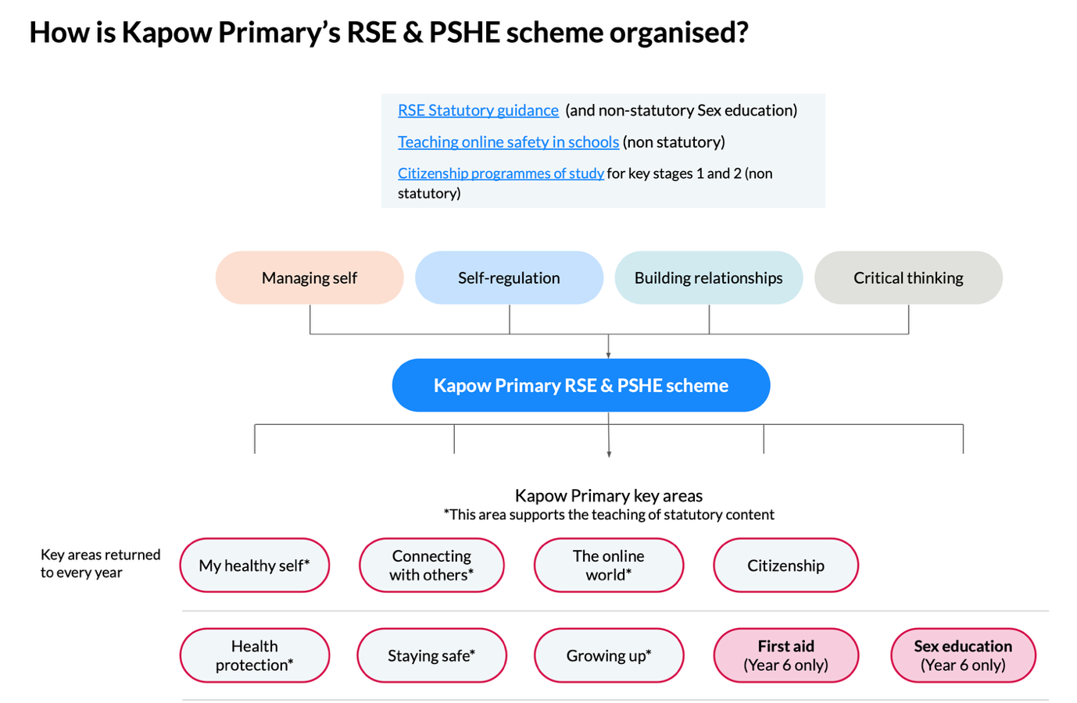

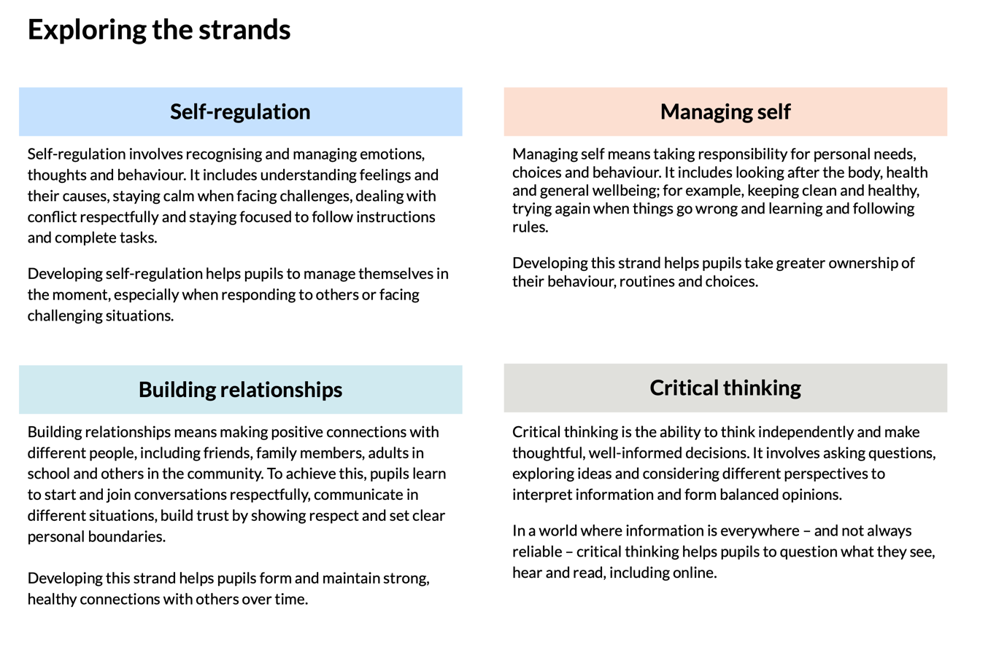

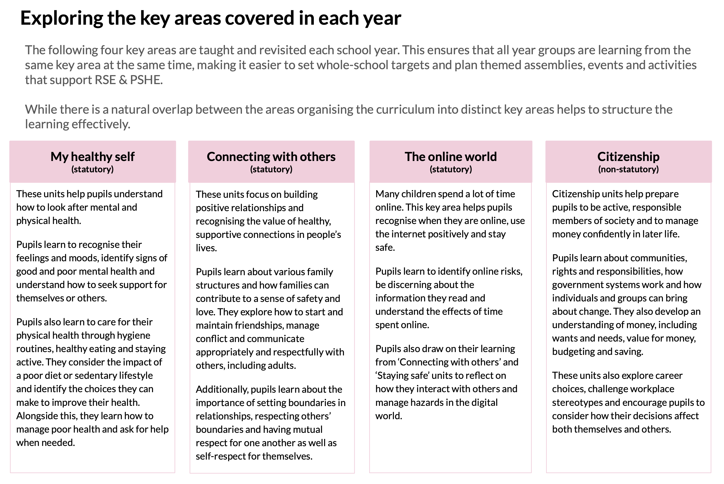
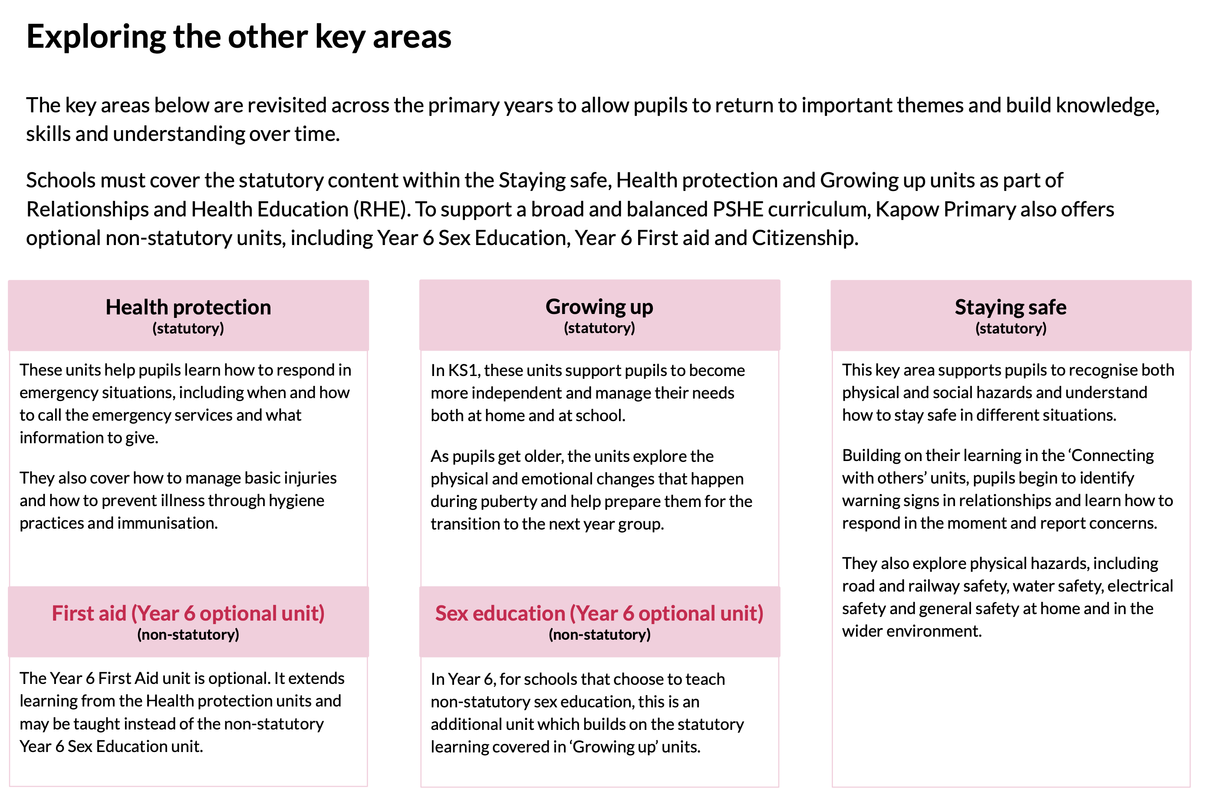
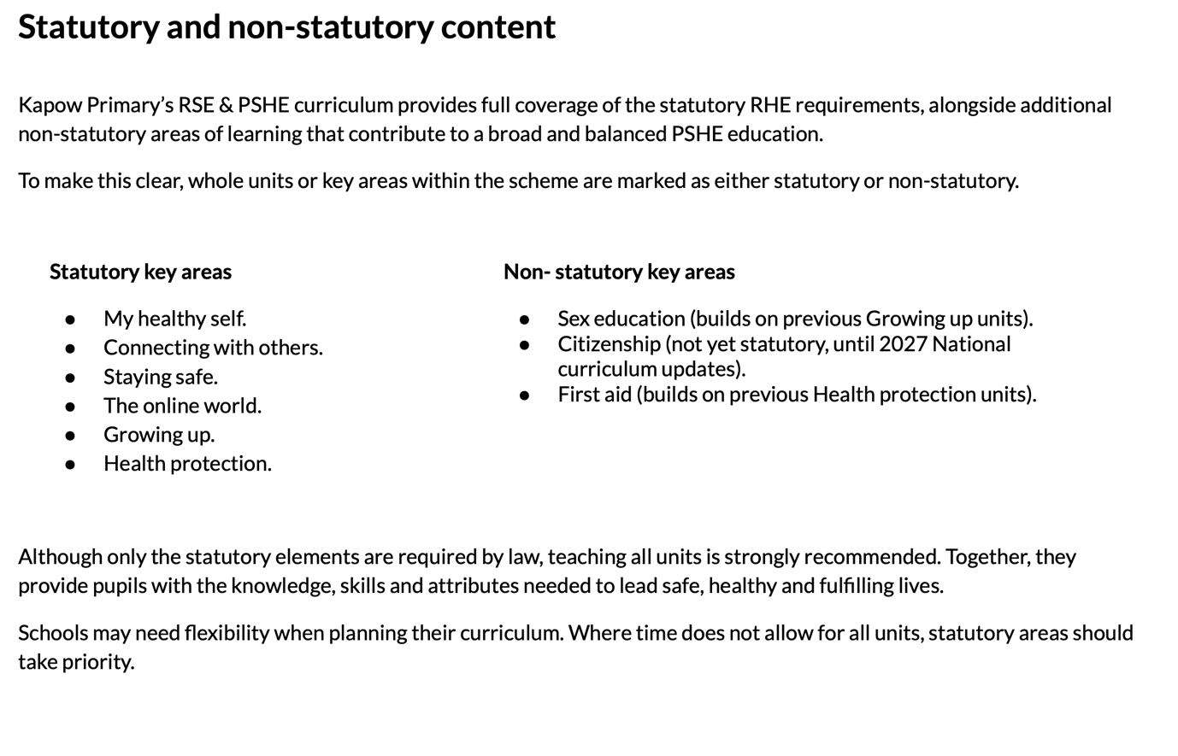
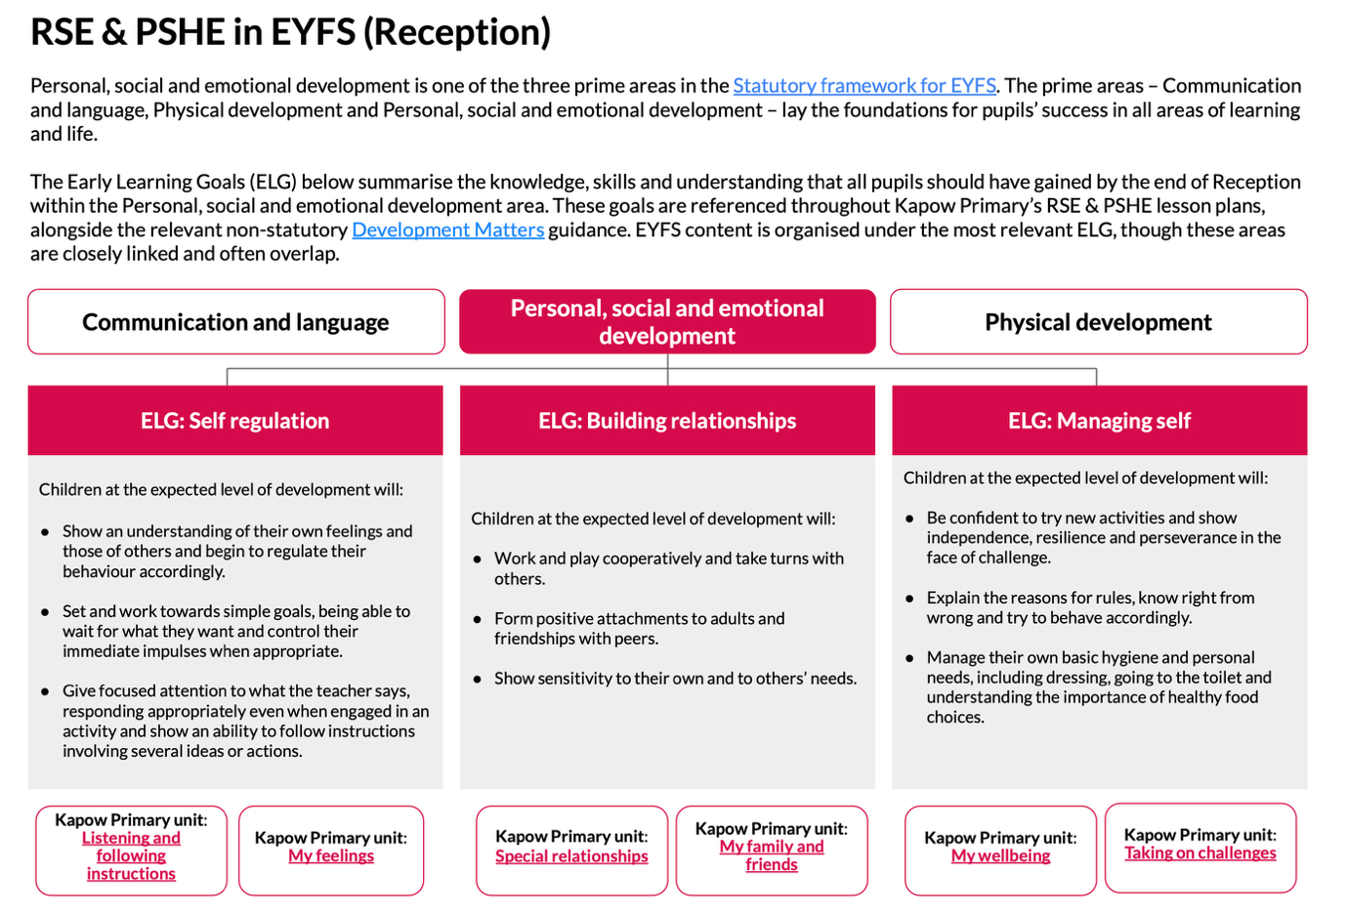
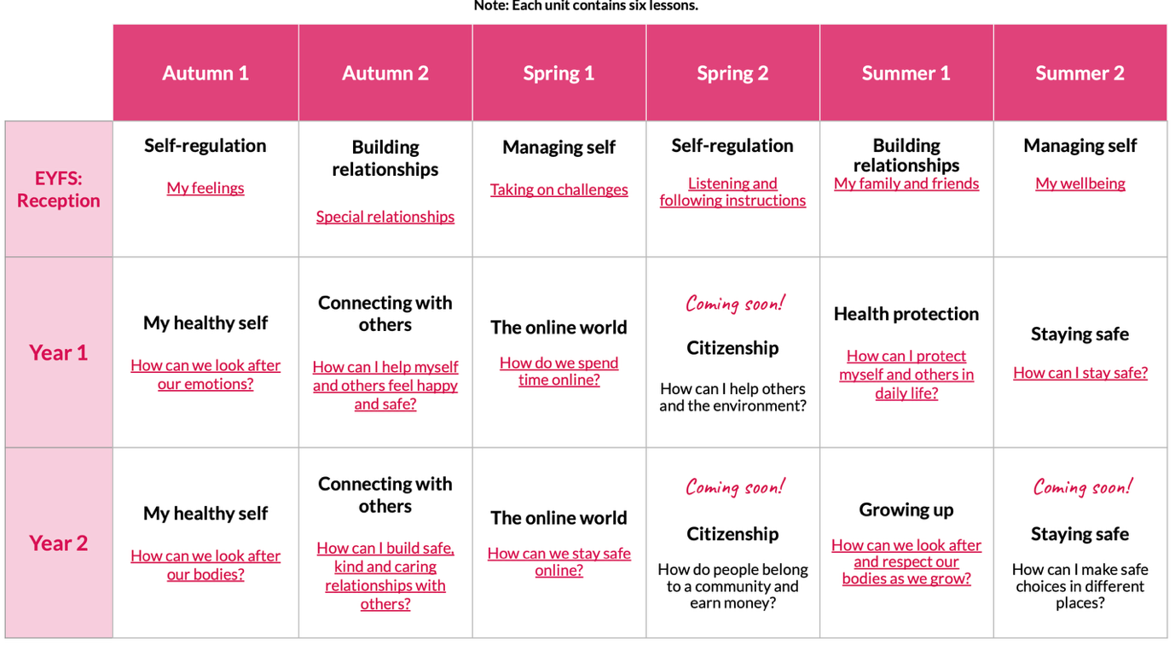
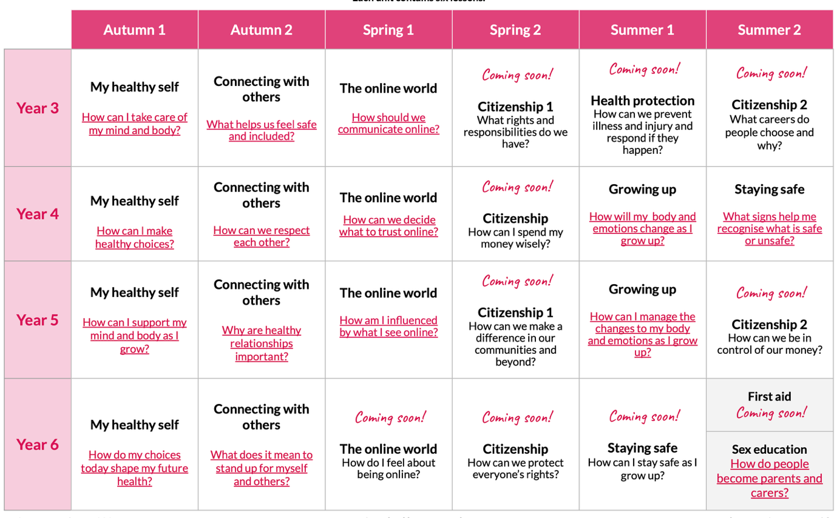
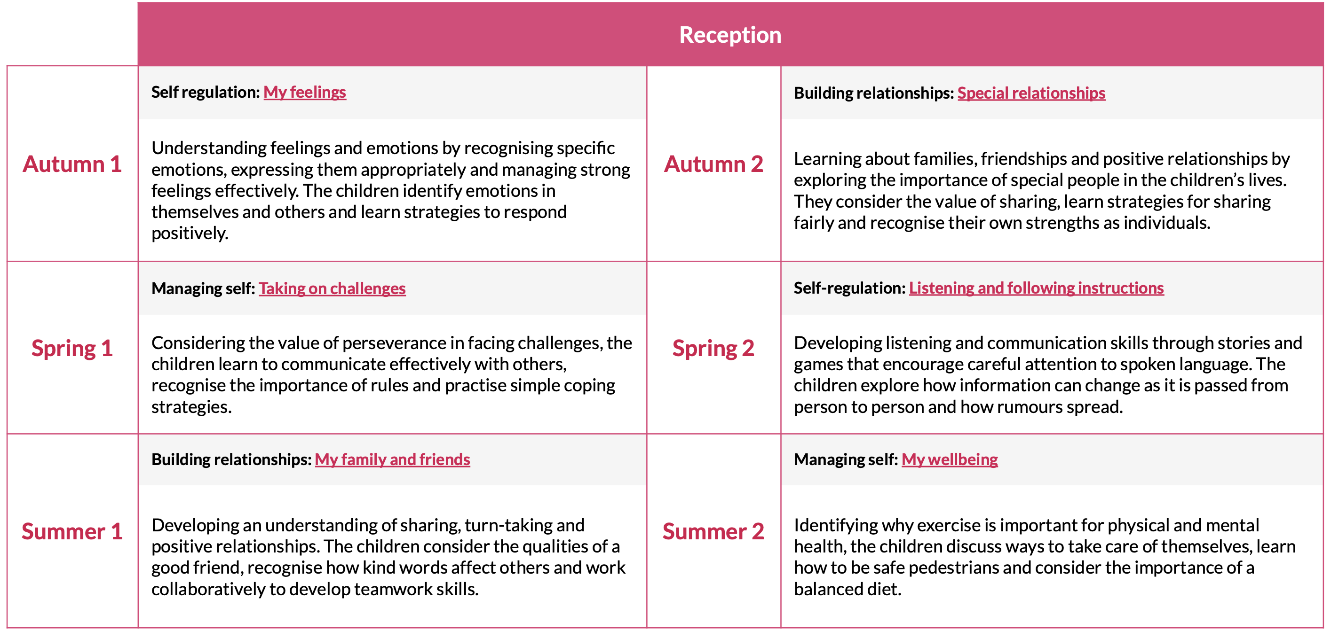
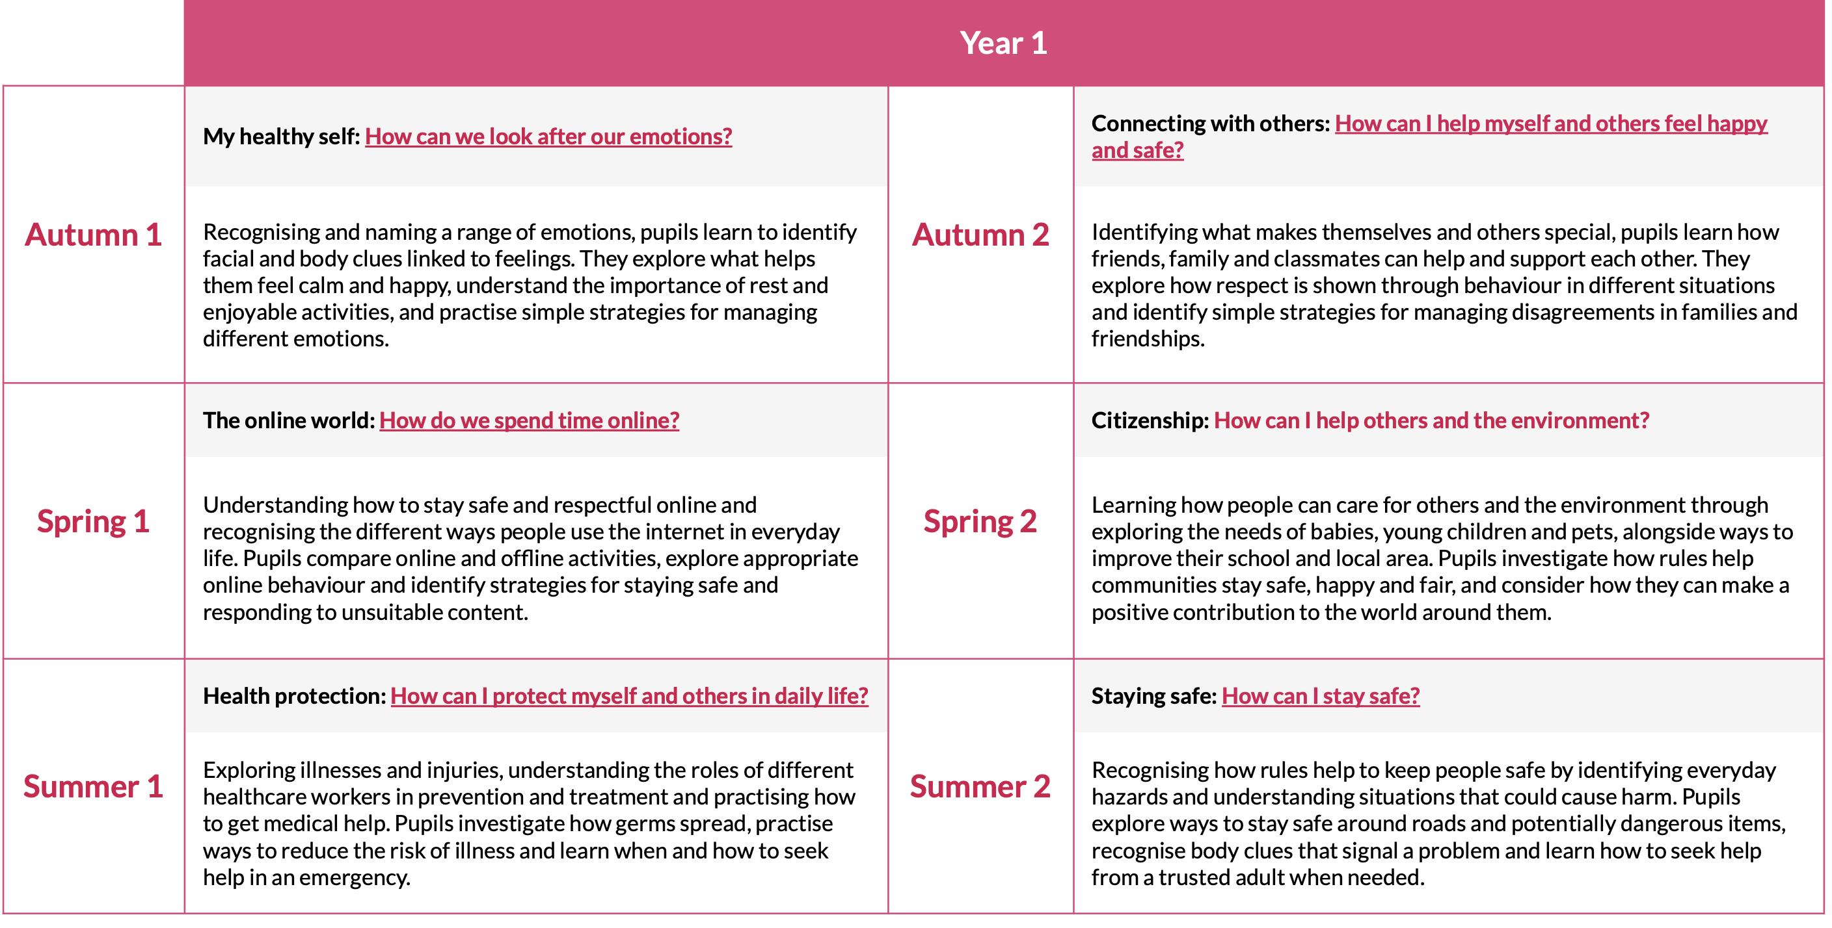
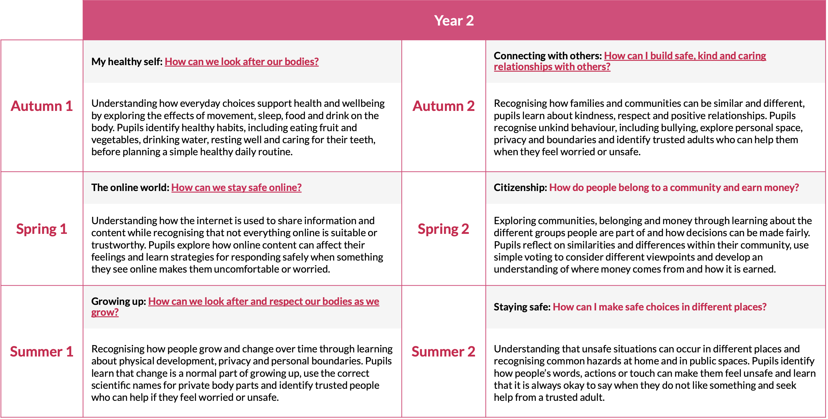
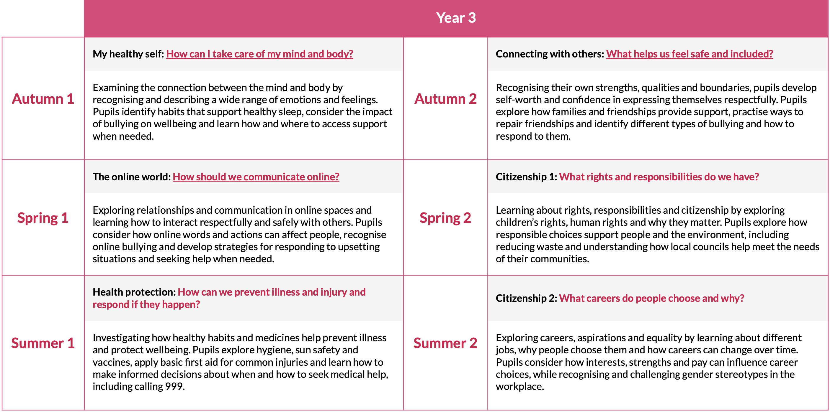
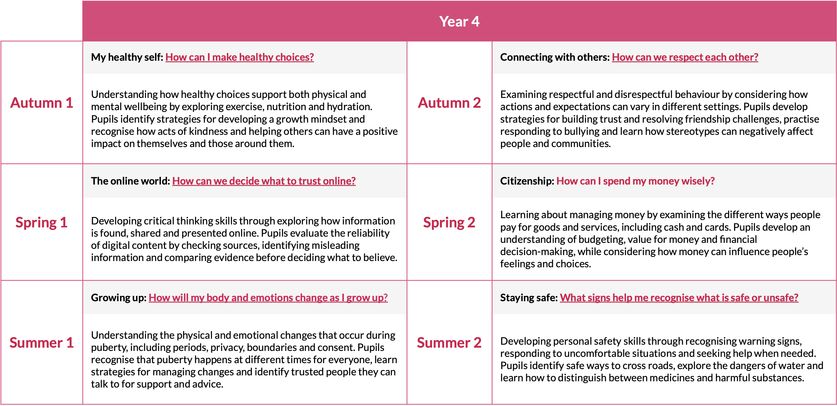
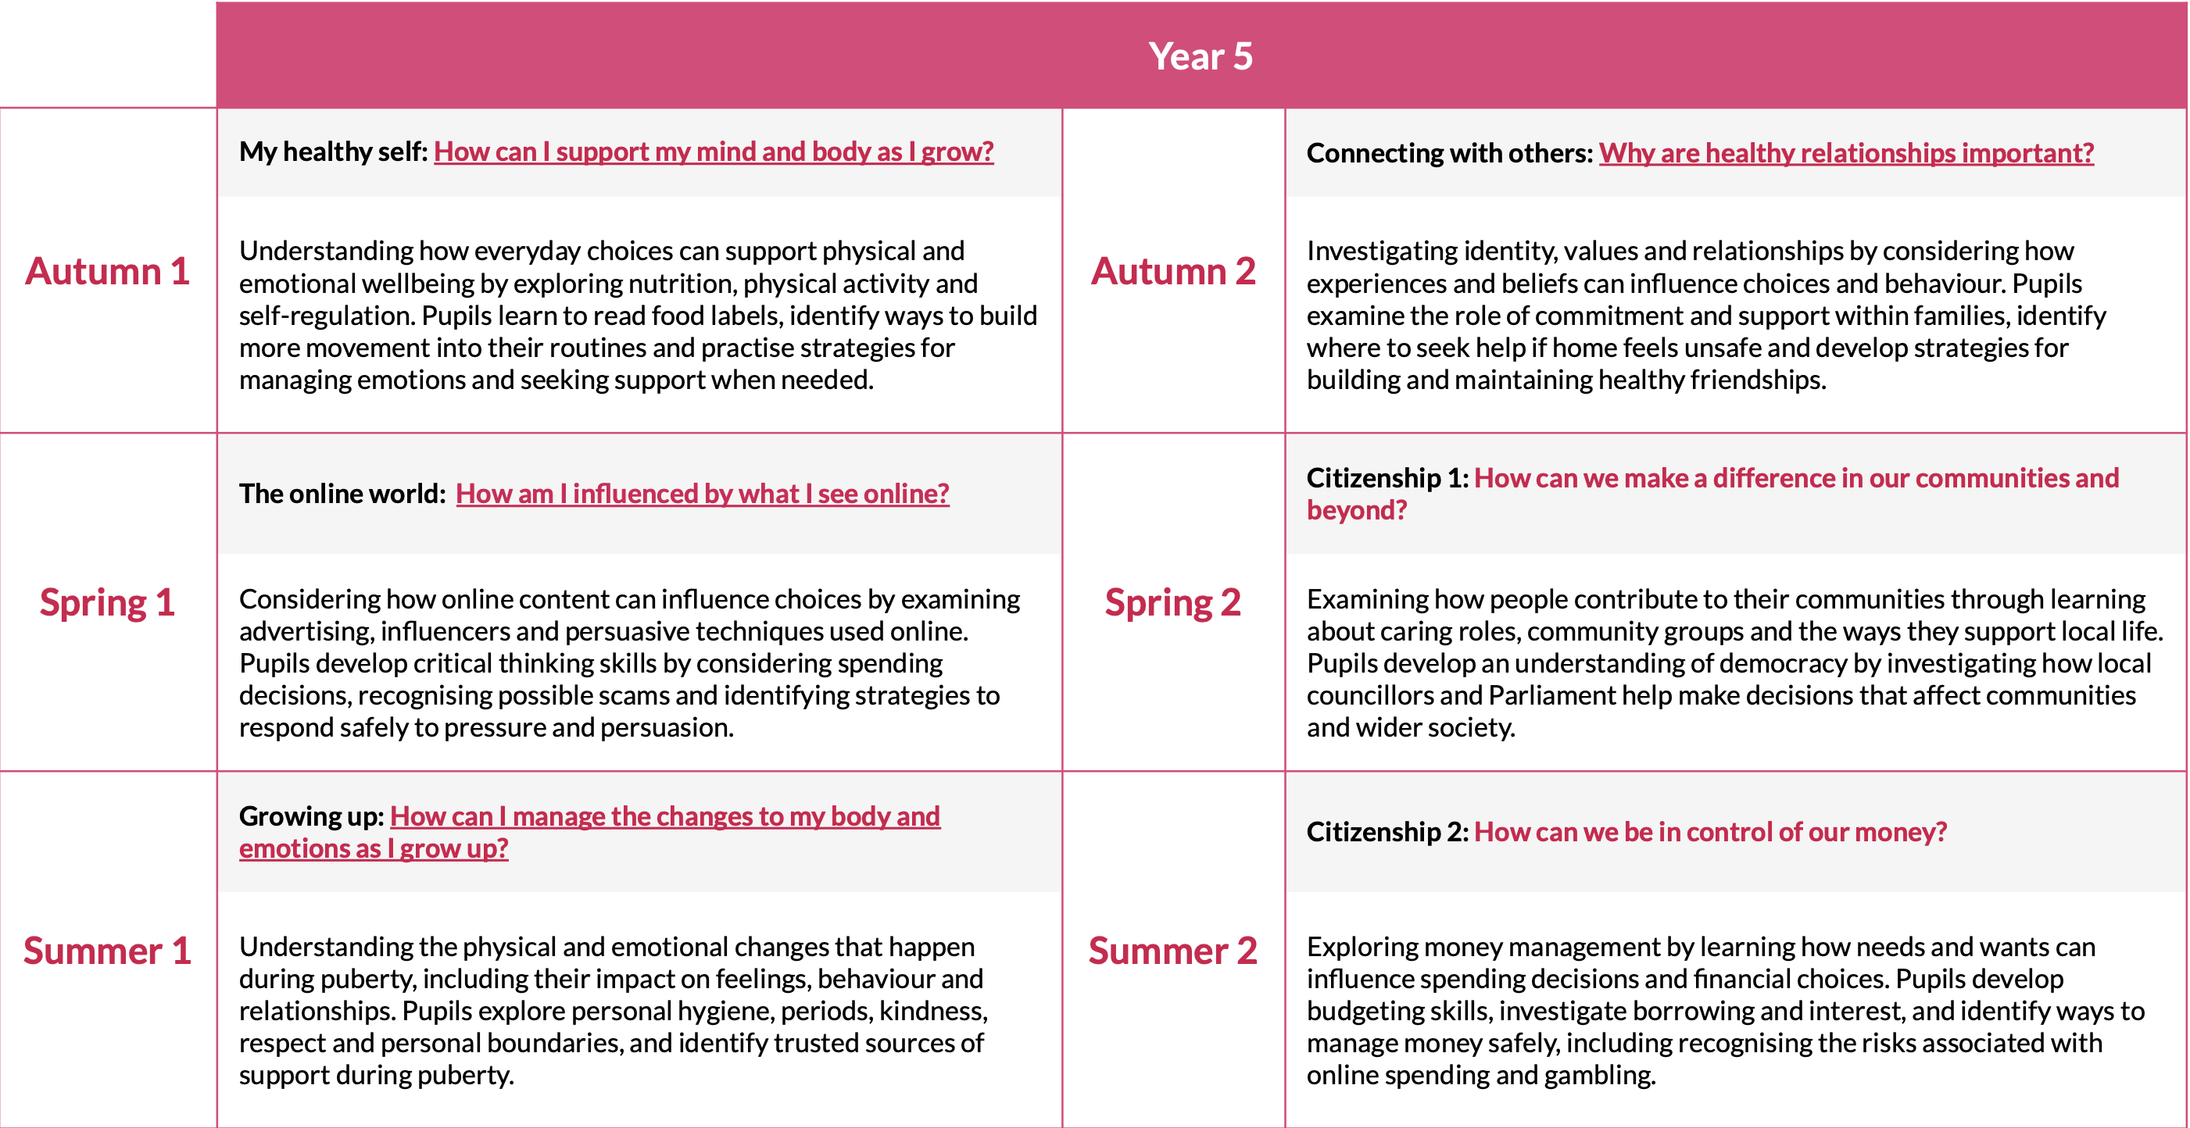
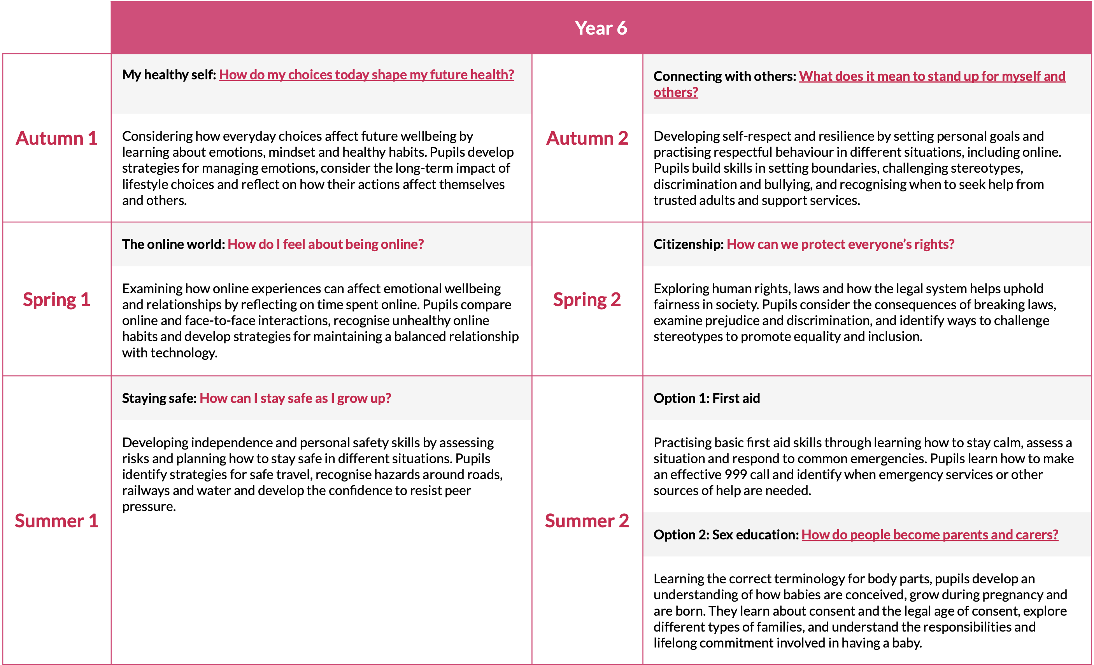
Appendix B – Puberty and Changing Bodies Pathway
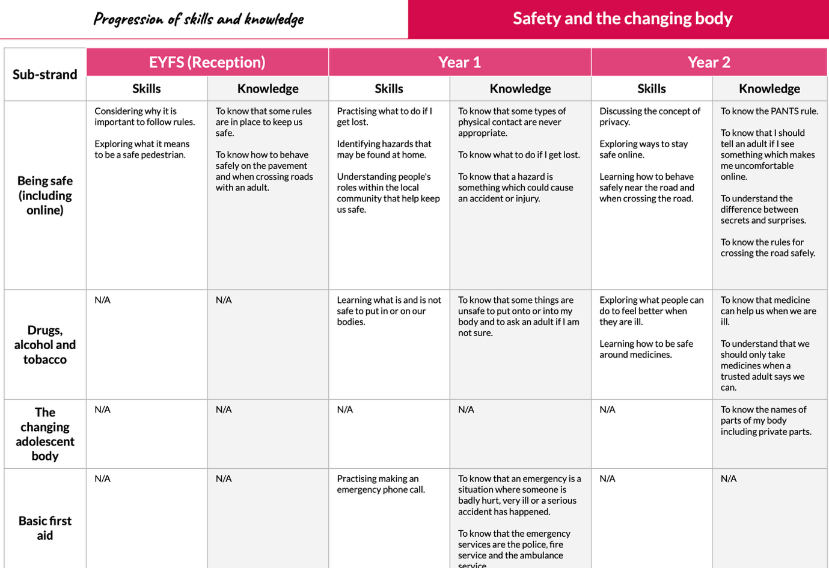
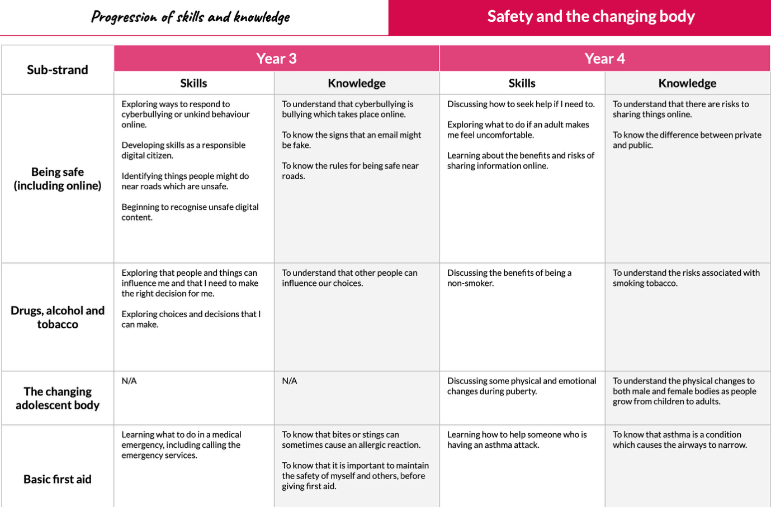
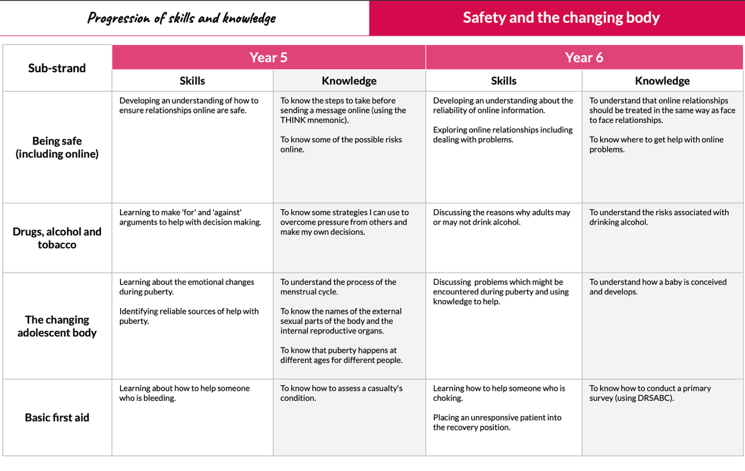
Appendix C – Parent Consultation and Curriculum Communication Arrangements
Annually, parents are directed to the school website where information on the curriculum coverage of RSE for each year group can be found. They are also reminded of their rights to withdraw and encouraged to discuss any concerns with key staff. Parents are able to access the lesson content via a written request to the Headteacher. At request parents are then given access via a log in using their email to the Kapow platform to review the curriculum documentation.

